Figen Suchanek

6004: Theoretical and Physical Methods

Prof. Foley

4/19/2019

1. As we increase the dielectric constant of the surrounding materials, the absorption peak increases. In our simulations, we took dielectric constants for glass n=1.45 and for alumina n=1.76 (Please see Fig. 2 and 3) for a 3 nm Ag particle. We found that absorption peak for glass is around 1\*10-16 and for alumina is around 1.6 \*10-16. The absorption peak was higher for alumina.

Initially, we took the water as surrounding environment in our simulations (Fig. 1).

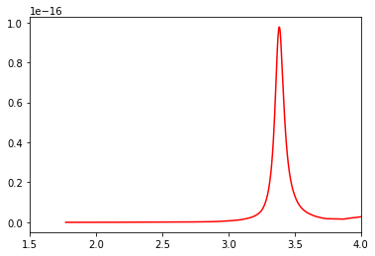

Figure 1. A 3 nm Ag nanoparticle in water (refractive index =1.33)

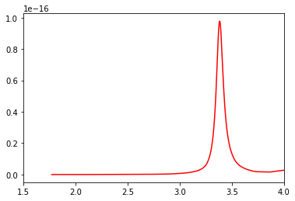

Figure 2. A 3 nm Ag nanoparticle in glass (refractive index =1.45)

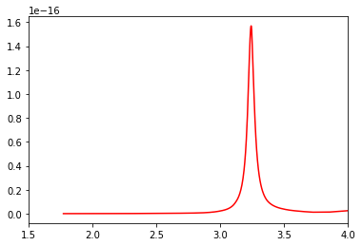

Figure 3. A 3 nm Ag nanoparticle in alumina (refractive index =1.76)

2) As we decrease the dielectric constant of the surrounding materials, the absorption decreases for air compared to absorption of glass and alumina. We took n=1.0 for air and the peak absorption was observed around above 6\*10-17. The absorption peaks for glass n=1.45 (absorption is around 1\*10-16)and for alumina n=1.76 (absorption is around 1.6\*10-16) were higher than the absorption peak for air (6\*10-17).

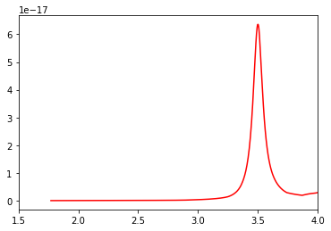

Figure 3. A 3 nm Ag nanoparticle in air (refractive index =1.00)

3) When we use Au instead of Ag, Ag nanoparticle shows higher absorption peaks. For example, the Ag nanoparticle absorption peak was observed around 1\*10-16 and it was higher than the Au nanoparticle absorption peak (6\*10-18 ) for the same refractive index (Fig. 6). Also, we see the same trend for Au nanoparticle, as we increase the dielectric constant of the surrounding materials, the absorption peak increases. Also, absorption graphs for Au nanoparticle were shown for different surroundings in Fig.5 and Fig.8.

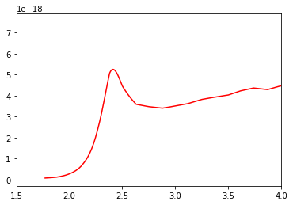

Figure 5. A 3 nm Au nanoparticle in water (refractive index =1.33)

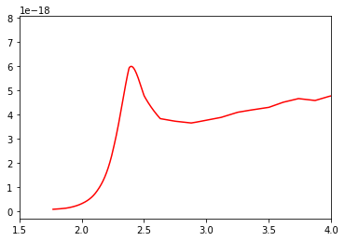

Figure 6. 3 A nm Au nanoparticle in glass (refractive index =1.45)

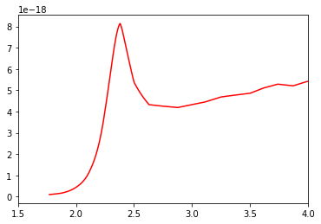

Figure 7. 3 A nm Au nanoparticle in alumina (refractive index =1.76)

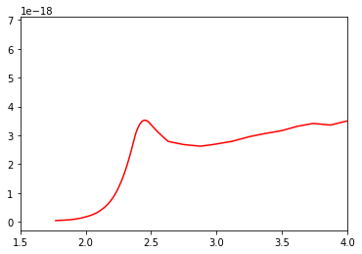

Figure 8. A 3 nm Au nanoparticle in air (refractive index =1.00)

4) In the simulations shown in the below, it was assumed that water was surrounding environment and it’s refractive index n=1.33 (Please see the code).

When we plot the real and imaginary part of the dielectric function of Ag as a function of wavelengths, the strong absorption peak was observed around 6\*10-24. In Fig. 9, blue plot shows the imaginary and red plot shows the real part of the dielectric function. The higher imaginary part of the dielectric absorption peak leads the higher absorption peak. It is a very good feature for designing nanoparticles.

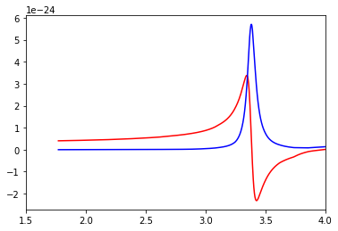

Figure 9. Real and imaginary part of the dielectric function of a 3nm Ag particle

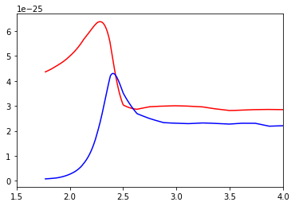

Figure 10. Real and imaginary part of the dielectric function of a 3 nm Au particle.

When we plot the real and imaginary part of the dielectric function of Au as a function of wavelengths, the strong absorption peak was observed around 6.5\*10-25. In Fig. 10, blue plot shows the imaginary and red plot shows the real part of the dielectric function. On the contrary to previous result for Ag, the real part of the dielectric function of Au nanoparticle showed higher absorption peak.